EXPERIMENT- 19
Perform Edge Detection using Sobel Matrix along XY-axis
Aim
To write a Python code to detect edges in both horizontal and vertical directions using Sobel operators in OpenCV.
Code
import cv2
import numpy as np
from google.colab.patches import cv2_imshow
from google.colab import files
uploaded=files.upload()
image_path=list(uploaded.keys())[0]
image=cv2.imread(image_path,cv2.IMREAD_GRAYSCALE)
if image is None:
print("Error: Image not found")
else:
sobel_x=cv2.Sobel(image,cv2.CV_64F,1,0,ksize=3)
sobel_y=cv2.Sobel(image,cv2.CV_64F,0,1,ksize=3)
edge_image=cv2.bitwise_or(np.uint8(np.absolute(sobel_x)),np.uint8(np.absolute(sobel_y)))
print("Original Image")
cv2_imshow(image)
print("Edge Detected Image")
cv2_imshow(edge_image)

Input & Output Image
Edge Detected Image
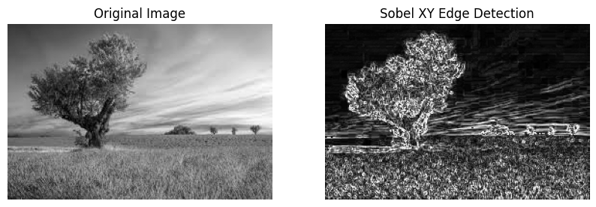
Result
Thus, edges in both X and Y directions were successfully detected using Sobel operators in OpenCV.

